Geethika.Challagolla
geethikachallagolla0@gmail.com
Batch No-126
Date- 02-08-2024

Create two S3 bucket in different regions, upload a file in one S3 bucket and transfer the same file from one S3 bucket to other S3 bucket.
1. Create two S3 buckets in two different regions.
Created one S3 bucket in Sydney Region and other one in seoul region following same steps.

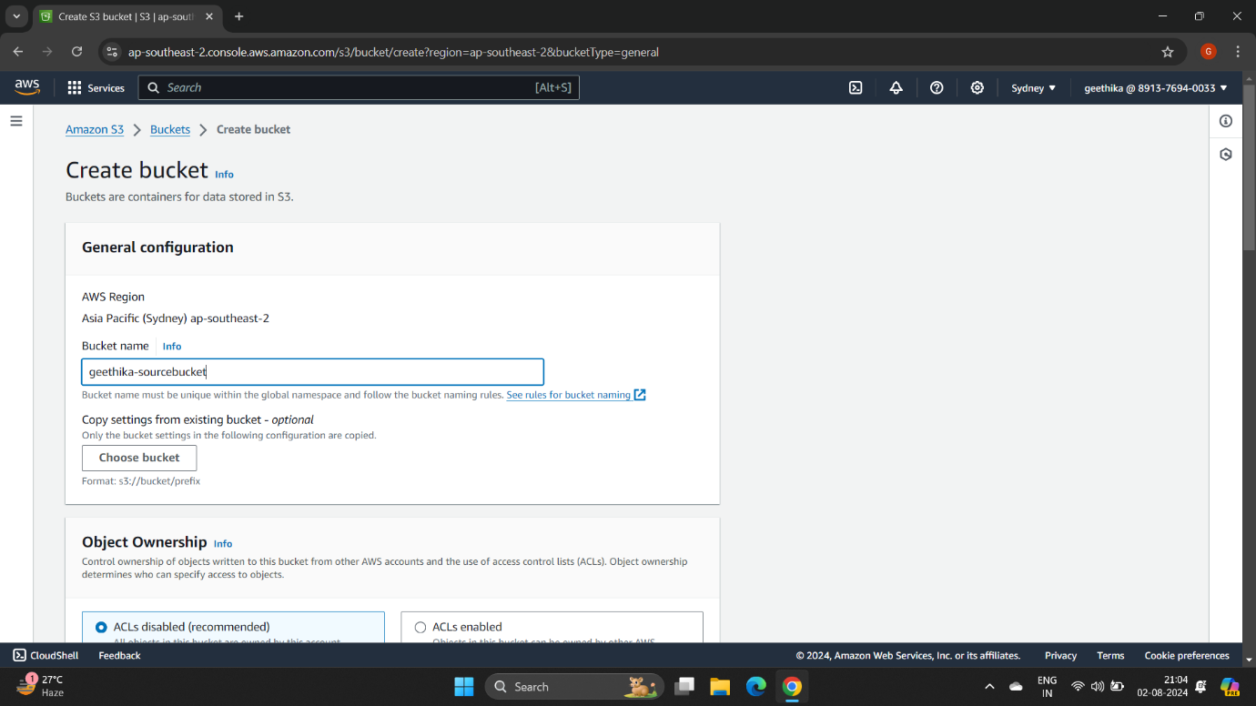
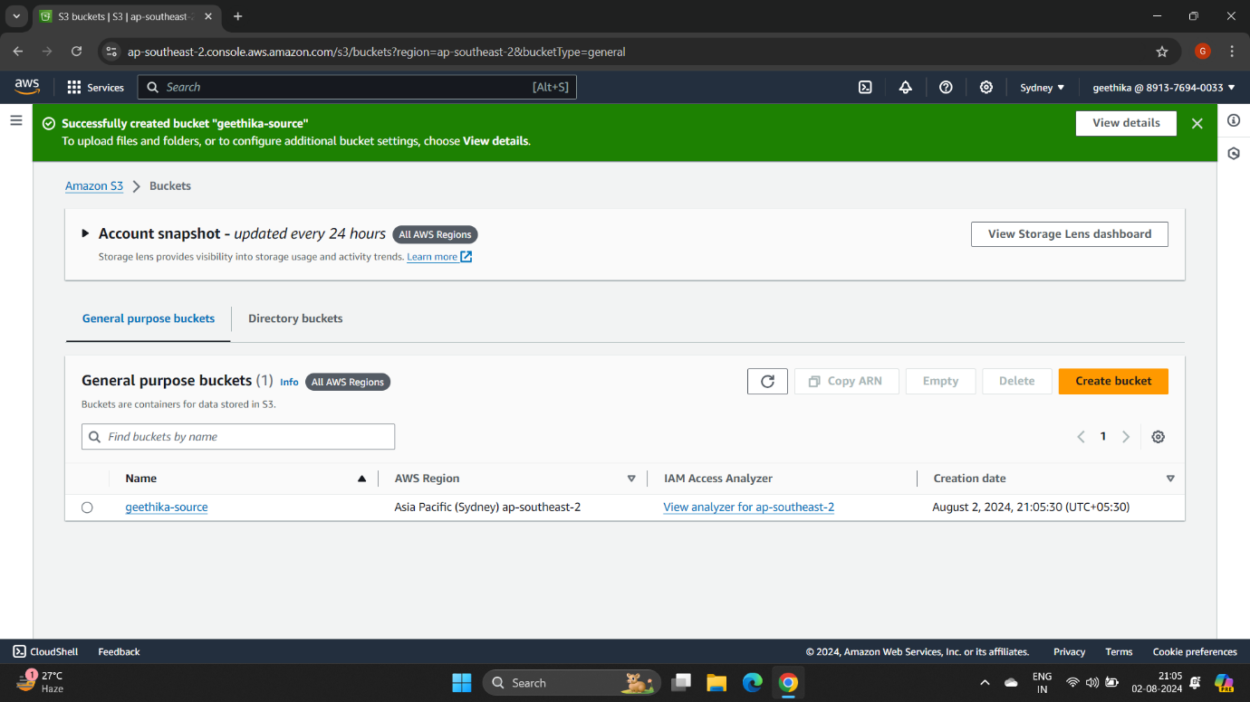

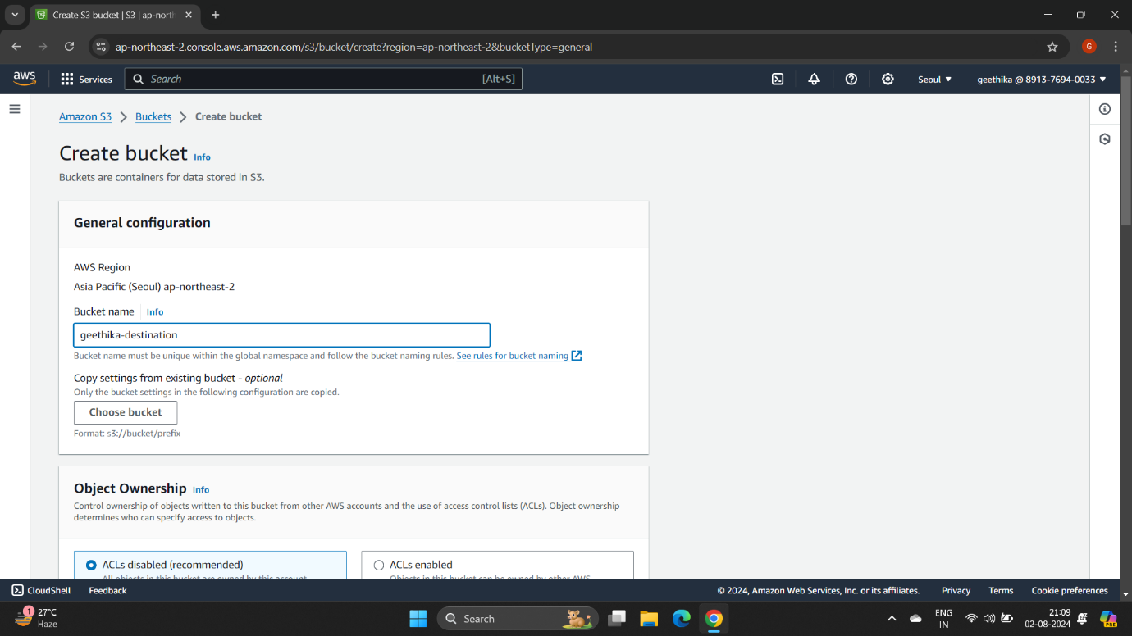

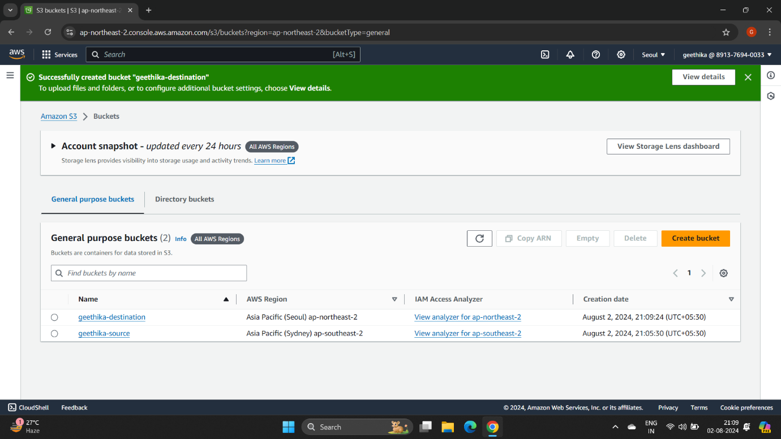

2. Upload one file in the source bucket.

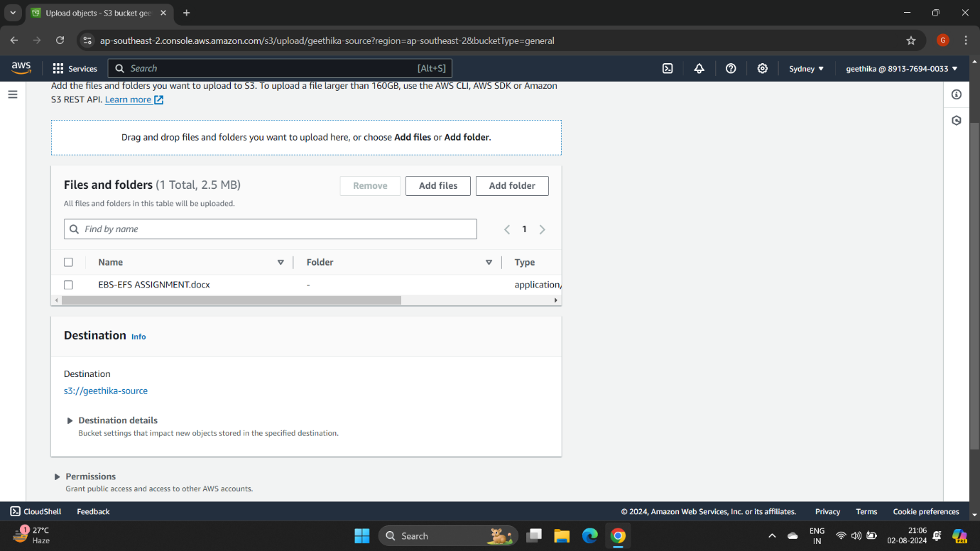
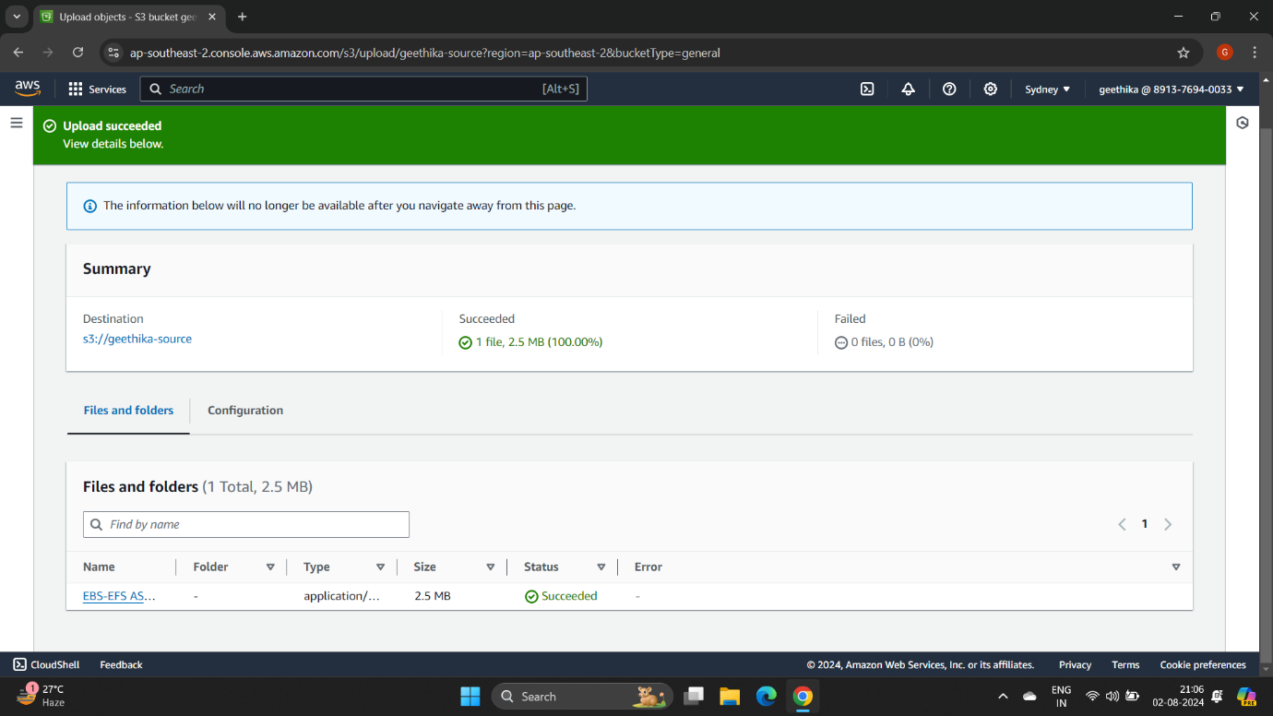

3. Go to management in source bucket and go to Create replication rule.

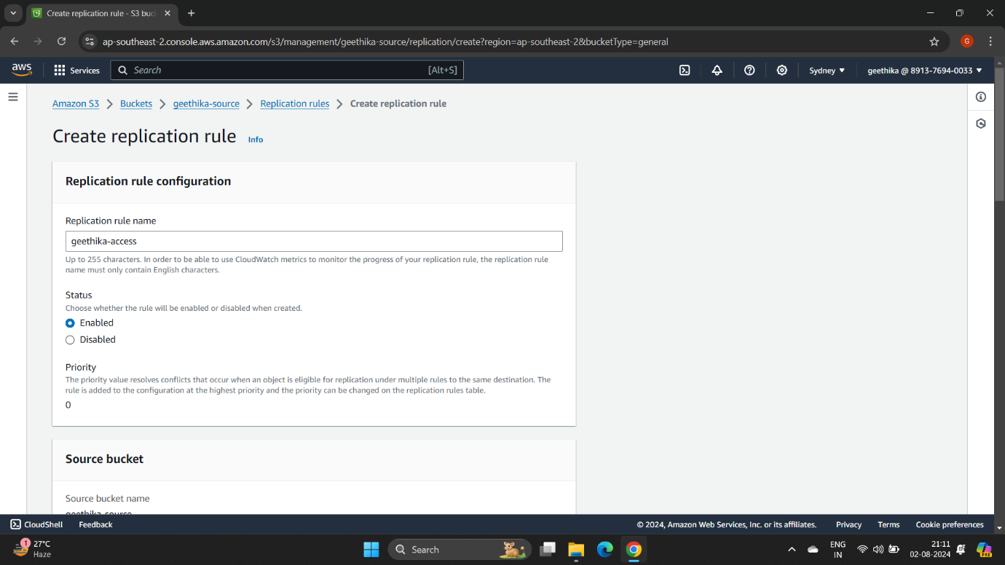
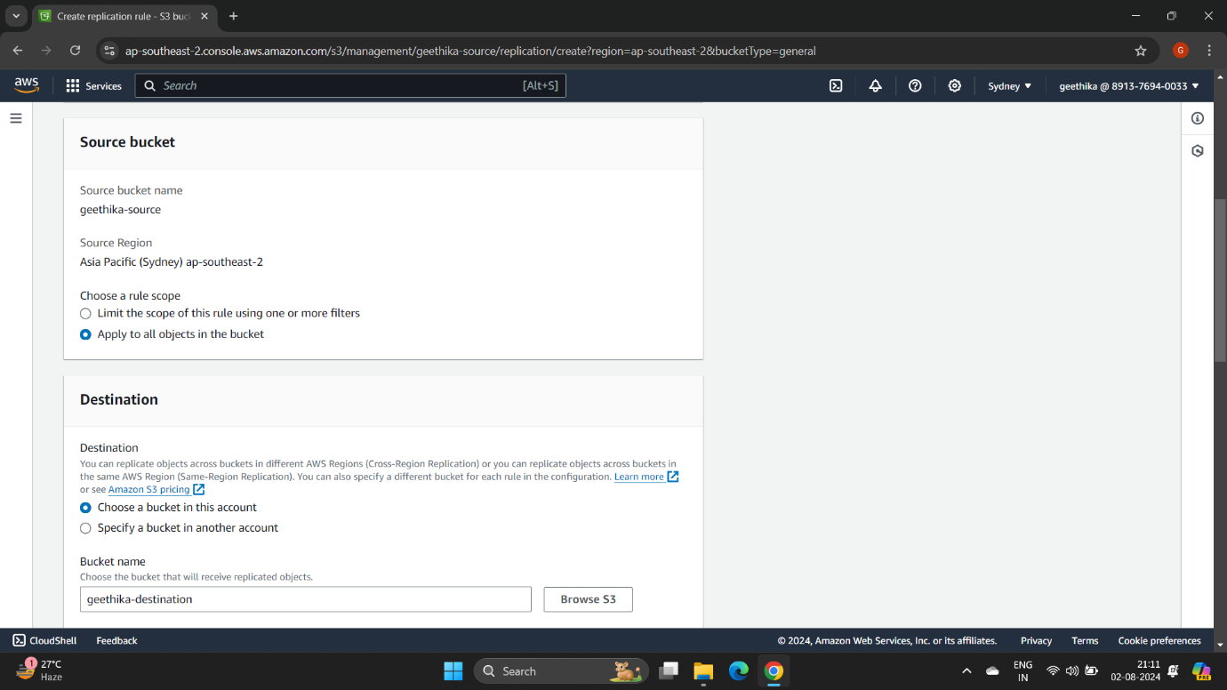

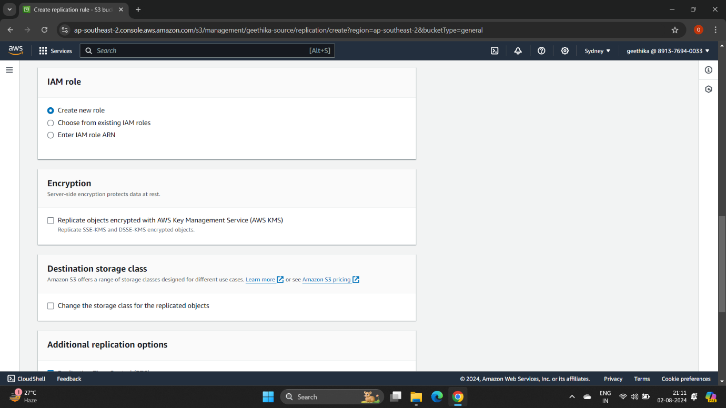

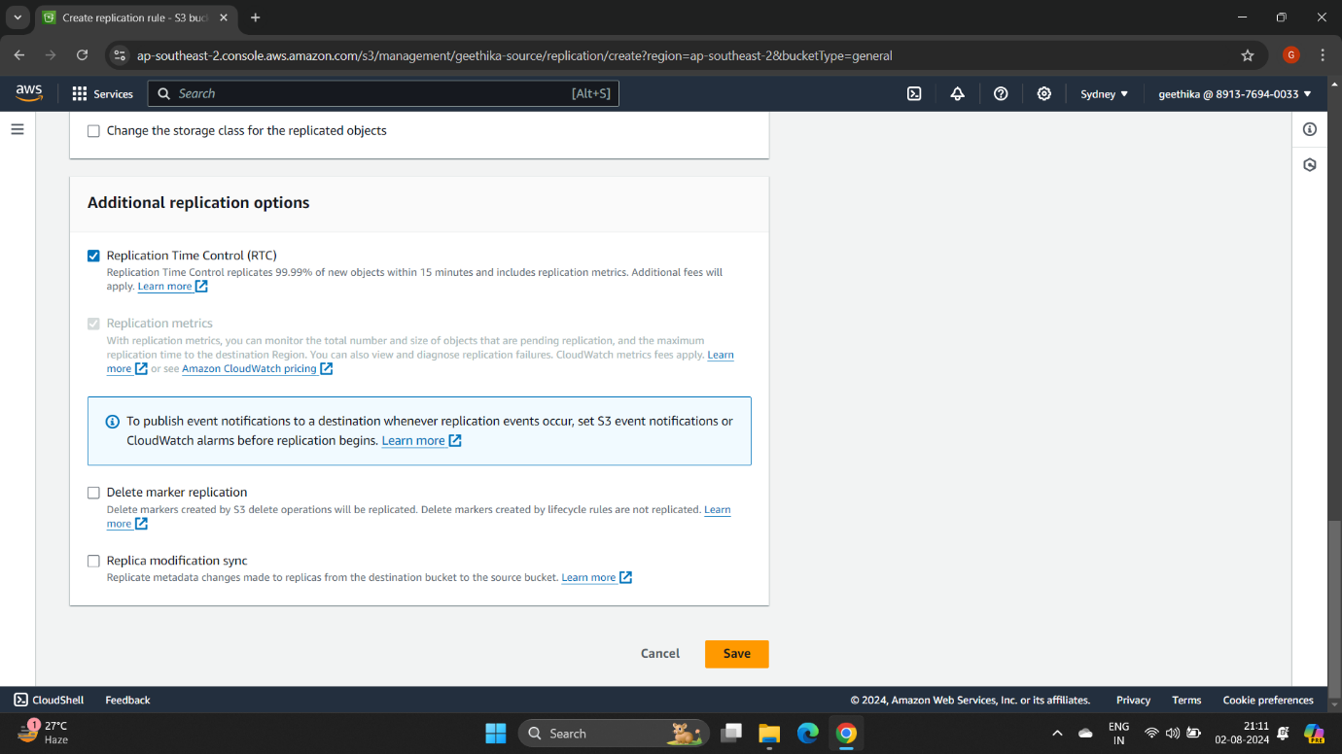

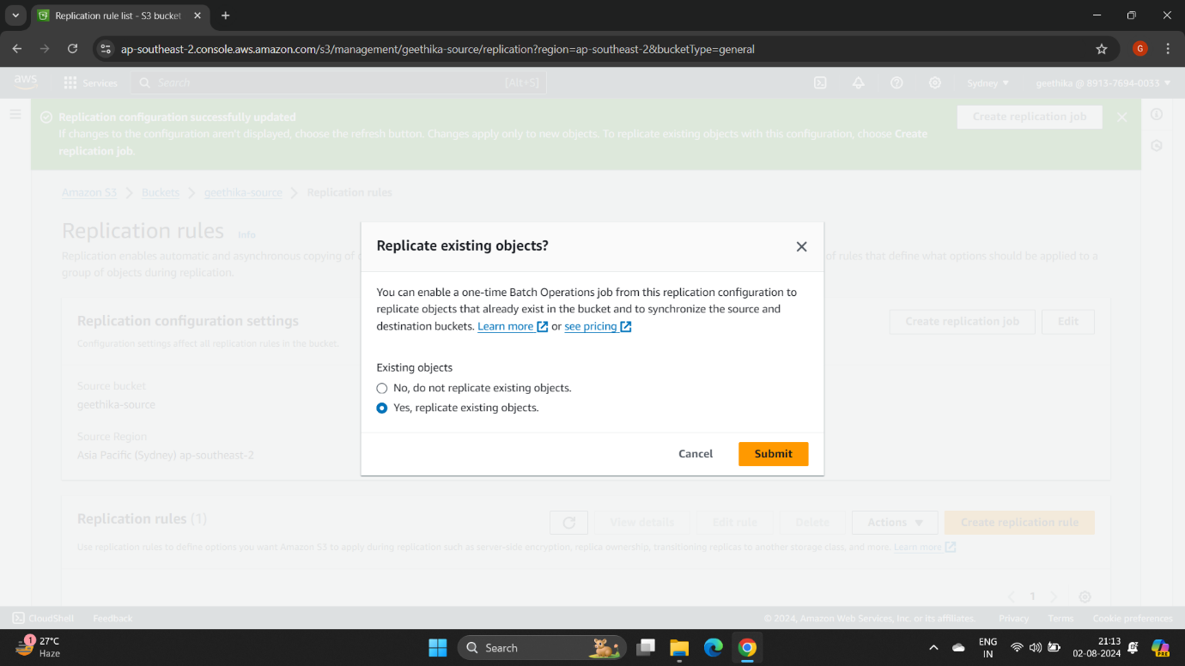

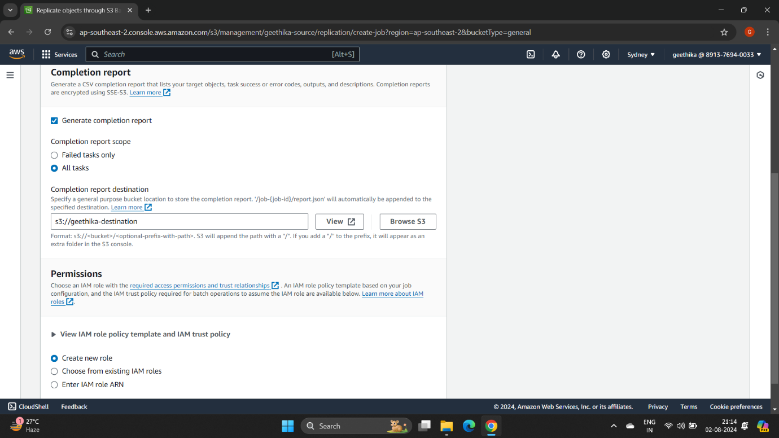

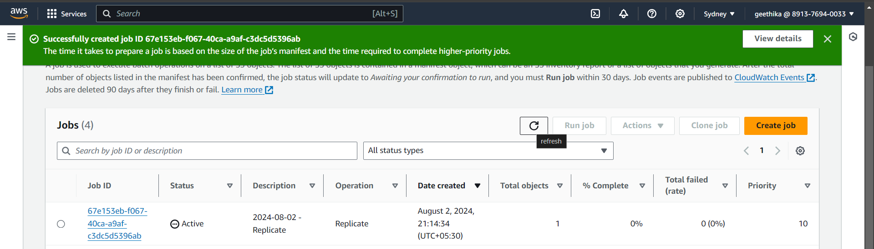

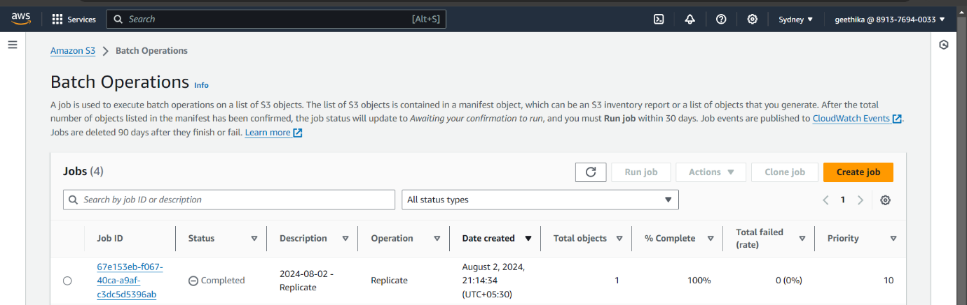

4. After uploading file in source bucket wait for few minutes, and check for file in destination.

